

Digital Collections Stewardship Workbook

Action planning workbook for the DCS course series  
  
OCLC/WebJunction 2024

# The Digital Collections Stewardship Workbook

This workbook contains the activities for all 7 DSC courses. As a whole, it is also intended to serve as an action plan for your overall digital collection stewardship work, creating unique digital collections at your library, archive or museum that preserve unique local history, culture, stories, and artifacts.

The courses and this workbook will lead you through planning your digital collections work during the five digital stewardship lifecycle stages: Prepare, Gather, Enhance, Save and Share.

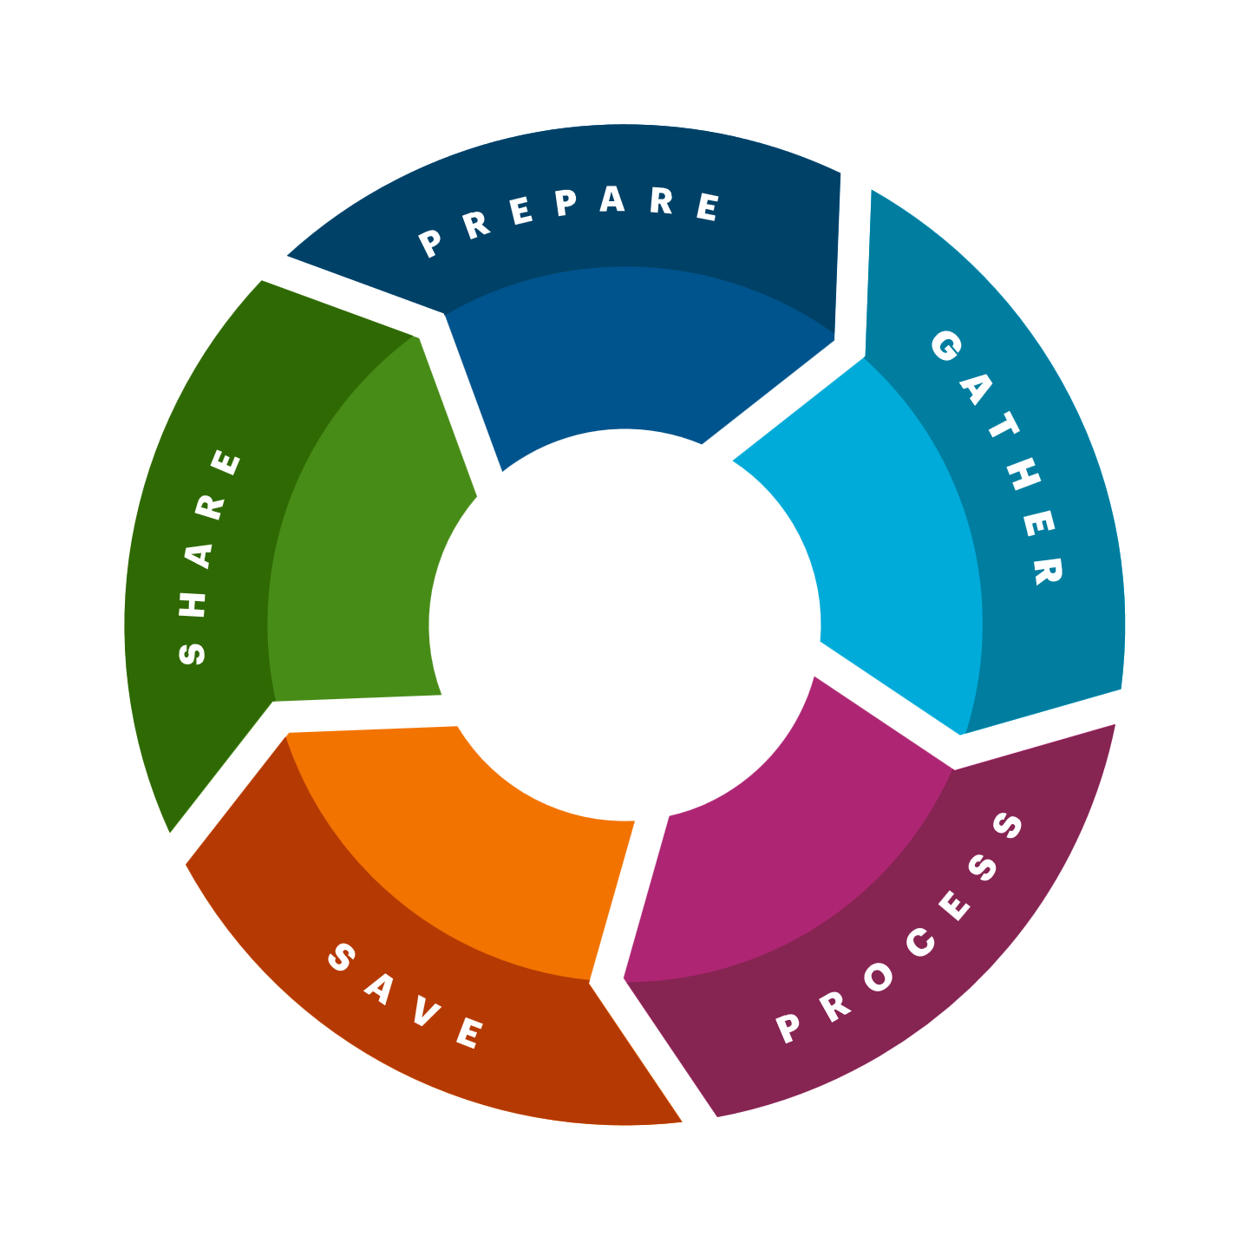

These activities can be done individually, or with colleagues, though we highly recommend involving others at your institution and in your community in this work.

# Digital Collections Stewardship 1: Introduction

## Activity 1: Digital collections

You have been introduced to the definition of digital collections, what they might reflect about your community, and the types of items they might include. On the **Digital Collections Examples** slide, practitioners at six small institutions described the digital collections they have created.

1. Choose one of the six institutions from the **Digital Collection Examples** slide. Listen again to their description and look through their digital collections. What do you like about the collections (e.g., content, organization, presentation, searchability, quality, descriptions)? Inspired by what you discover there, what elements would you want to include in your digital collections?
2. List any digital collections your institution currently has. Note who is responsible for creating and maintaining them.
3. List ideas you have for new digital collections. These could be things you have already been thinking about, or new ideas. What are some possible themes for them? What kinds of stories and histories would you like them to tell? What kinds of items might go into them? *(It’s OK if you’re unsure, we’ll revisit this question in the next course!)*

## Activity 2: Focusing on your community

To get started thinking about the Digital Stewardship Lifecycle, take time to reflect on your community and institutional values, culture, and languages.Before discussing community or cultural needs, it is important to understand who makes up your community, including Indigenous groups that steward or have stewarded the land you live on. We encourage you to discuss these questions with colleagues as well.

1. Who currently lives in your community, and who has lived there in the past? Which cultures, groups, and languages are represented in your community?
2. Which groups are represented in your collections? Which groups have been left out or overlooked in your collections? Whose histories and voices might you include to tell a fuller story of your community?

1. Which groups have a voice in your library decision-making? Who is currently consulted? Who is left out of these conversations?
2. Who else in your community should have a seat at the table when it comes specifically to making decisions about creating, organizing, preserving, and sharing digital collections?

## Activity 3: Digital Stewardship Lifecycle customization brainstorm

Brainstorm some ways that you might customize your Digital Stewardship Lifecycle and your digital collections work to better serve your community and institutional needs. Record all your ideas below.

We’ll come back to this list later in the training. For now, these are just possibilities to consider.

# A Community-Centered Approach to Digital Collections

## Activity 1: Popular and lesser-known narratives

Take a moment to write down any existing digital collections as well as ideas you have for new projects. Then, consider the stories each collection tells. Does it tell a more dominant narrative? Or does it include stories of less commonly documented communities and voices? If you’ve taken **Digital Collections Stewardship 1: Introduction** and **completed Activity 2,** refer to your notes in your workbook to compare how well your current plans represent the full range of experiences in your community.

## Example:

Existing collection: Digitized newspapers   
Newspaper articles often reflect the priorities and values of the dominant voices in a community to write and shape the news, especially those in power.

Idea for new collection: Oral histories from veterans   
Complementing a collection of digitized newspapers with first-person narratives from people with connections to historical events can help to create a fuller picture of the lives and histories beyond the headlines.

## Activity 2: Brainstorming connections

This brainstorm is intended to provide a starting point for possible relationships and connections that could bring more diverse voices and perspectives to your digital collections work. ​

Choose the option that feels most useful to you. ​

1. **Your connections within your organization**: If you work for a large organization, draw a map or make a list of all the meaningful connections you have to other departments within your organization. For example, if you work in technical services but are friendly with a colleague who’s a children’s librarian, draw the connection between yourself and that colleague.​
2. **Your connections to your communities**: Draw a map or make a list of your connections to groups or organizations where you feel you personally belong; this can give you an idea of starting points where you already feel comfortable. This might include schools, religious organizations, gyms, volunteer groups, or other groups.​

## Activity 3: Reaching out

As you continue through this section, write down some notes to yourself about how these topics might apply to your work:

* What does moving at the pace of trust look like for you as you expand your network to include more communities and more perspectives?
* What strengths do you have that can help you reach out to new communities? What might you need to work on?
* What concerns do you have about beginning this work? For instance, is there any history related to a community you want to reach out to that might affect trust building?

* What do you need to do or learn about before you begin this work?

* What existing events or celebrations could you use to build your network, connect with new communities, and perhaps gather memories related to digital collections projects?

## Activity 4: Sustaining relationships

Write down any ideas about your next steps in this section. You can respond to these prompts or add anything else that you think of.​

List any strategies for maintaining relationships in your current and future digital collections projects that you want to keep in mind.

The course mentions utilizing newsletters, social media, a website, and print materials as communications channels with your communities. Write down any existing or new channels you might use to keep your organization and digital collection project visible.

# Digital Collections Stewardship 2: Preparing

## Activity 1: Group brainstorm: Digital stewardship goals

If possible, we recommend working with colleagues to brainstorm answers to the question below (this also works as an individual exercise).

**First**, write as many ideas as you can for each question on a large surface like a whiteboard or large sheet of paper.

**Next**, narrow down your responses for each question to the few ideas that seem most important. Write those down below. You’ll use these answers when creating your Digital Stewardship Purpose Statement later in this course.

1. Why do you want to create and share digital collections with your community?

1. What existing opportunities for collections do you have? How might these opportunities serve and support your community?

1. What are some challenges you might face? Who might you talk to or collaborate with to come up with ways to respond to these challenges?

Activity 2: Digital stewardship purpose statement

Use this space to begin drafting your purpose statement. You can refine this as you go.

1. Write down some key statements from your organization’s mission, goals, values, and/or objectives.

1. Write down what is known about your community’s needs and values that are relevant to your digital collections work. *Refer to the “Focusing on your community” activity from the Course 1 workbook.*
2. Take the most important goals and objectives for your digital collections that you recorded in the **Group Brainstorm: Digital Stewardship Goals** activity. Refine and combine these so you end up with one or two statements that best align with your organizational goals and community needs. Be specific about who will benefit.

1. Start drafting a short (2-4 sentence) purpose statement that connects your larger institutional goals (#1) and community needs (#2) to your digital collections goals (#3), to describe what you want to do and why you want to do it. *See the examples in the* ***Digital Stewardship Purpose Statement*** *section of the course*.

## Activity 3: Digital stewardship policies

Review your institution’s existing policies for any information specific to digital collections, including digitization, preservation, access, and use. Take note of whether these topics are addressed; if so, the names of the policies where they appear, and whether they need revising to provide guidance for your digital collections. If you’re not sure yet, that’s ok! We’ll return to these policies in later courses.

Note below the policy topics your institution has already documented, and indicate whether that documentation appears to be sufficient for digital collections:

* Digital Collection Development (e.g., criteria for inclusion of materials; guidelines for reappraisal and deaccessioning)
* Digitization (e.g., guidelines for identifying and prioritizing what to digitize)
* Digital Preservation (e.g., guidelines for securely storing digital collections)

* Donations (e.g., review procedures, criteria for acceptance, disposition of physical objects)
* Access and Use (e.g., metadata procedures, intellectual property, copyright and permissions, conditions of use, such as non-commercial or restricted)
* Any additional policies you think may be relevant:
* What’s missing in your existing policies? What new policies may you want to create? Who decides if new policies are needed? Who would be involved in drafting them? What is the approval process? Below, write down your initial thoughts about the need for future policy work.  
  *(We’ll explore specific policies in more detail in later courses, so you don’t need to create any new policies at this time.)*

## Activity 4: Guiding questions to set up your project

Use the guiding questions below to begin planning your first digital collections project. You can also refer to the examples and tips shared in **Guiding Questions** in **Section 4** of the course. You may not have all the information you need at this point. That’s fine, you can continue to refine and add information here as you work through the courses and plan your project.

**WHAT** project will you begin with? *(Consider starting small.)*

**WHO** will be involved? (Include employees, volunteers, internal stakeholders, external partners and community members.)

**HOW** will you complete the work? What tools, resources, or potential funding will you need? *(We recommend starting with what you have, where relevant.)*

**WHEN** will you do this work? What’s the timeline? (Give yourself more time than you think you’ll need and embrace flexible timelines for your first project.)

# Digital Collections Stewardship 3: Gathering

## Activity 1: What to include

As you learn about collections considerations in **Section 2: What You’ll Include**, note your initial thoughts on these four aspects of the items you will include in the collection you are planning.

1. Subject (Consider what subjects to include, and what is out of scope)
2. Cultural, ethical, or legal issues (Include at least how to manage and verify rights to display and share)
3. Physical items (If you accept them, what are your limits)
4. Condition (Consider minimum standards for digital, acceptable conditions for physical)

## Activity 2: How to gather items

As you proceed through **Section 3: How You’ll Gather Items**, record your thoughts when prompted about each of the three methods described. After taking time to reflect individually, we recommend talking through these options with others in your institution or community.

1. Community donations
2. External Partnerships
3. Creating new content

## Activity 3: Document the “what” and the “how”

Now that you have decided what types of items you’ll gather, and how you’ll go about gathering them, you can connect those decisions with either the policies you reviewed in **Activity #3 of Course 2: Preparing**, or with the appropriate procedures, forms, and collection-level documentation for each.

**Policies**  
Note which “what” or “how” collecting guidelines you think should be documented at the policy level, and the name of that policy (if known).

**Procedures**Note anything that represents an ongoing procedure, something you wouldn’t include in a policy.

**Forms**Note any process that will require a form, and whether one exists in your institution (include whether it will need updating).

**Collection documentation**  
List guidelines that are specific to your proposed collection but might also apply to any digital collection you develop.

# Digital Collections Stewardship 4: Digitizing

## Activity 1: Digitization process, equipment, and standards

As you learn about the process of digitizing different types of items, record your initial understanding of the process for your collection. If needed, make a copy of these questions for each item type you want to digitize.

Item Type:

1. Item type variations – describe the properties of items to be digitized. Include important details such as physical condition, size, media formats, etc.

1. Process options – given what you know, describe the digitization process you expect to use. If uncertain, note the options and your questions about them.

1. Equipment needs – list all physical equipment you think you’ll need. Indicate which ones you currently have, which you can borrow, and which might need to be purchased.

1. Software / file editing – describe the kinds of software you will need, whether you currently have it, and which you will need to obtain

1. File formats – refer to one of the technical guidelines from the **Digitization standards and technical specifications** slide to identify file formats and quality standards you might use. Note where you are not yet certain which ones to use.

## Activity 2: Strategies for digitizing

As you learn about the advantages and drawbacks of each digitization strategy, note those that relate to your situation. Also note where you need additional information or follow-up, and any decisions about each that you’ve already made.

1. In-house digitization, i.e., doing the work yourself

2. Sharing digitization work with a partner organization or institution

3. Hiring a digitization vendor

## Activity 3: Documentation

Note below which, if any, of these forms of documentation already exist at your institution, and which ones you might want to create. Briefly describe the scope of what you want to document, and any initial questions you might have about each one.

Digitization policy

Digitization guidelines and procedures

Digitization project plan

Digitization workflows

# Digital Collections Stewardship 5: Enhancing

## Activity 1: Folder structure and file naming

Review the digital collection project you identified in **Activity #4 of Course 2: Preparing**. With that project in mind, respond to the following questions with ideas for your folder structure and file naming conventions.

1. What is your current folder structure scheme? Does it reflect your institutional and workflow needs? Do you have more than four levels of folders?
2. Do you already have a file-naming scheme in place? Does it reflect your current file management needs? Does it include all your digital content?
3. Are you required by policies or mandates to name and save your digital files in a certain way?
4. Does your file-naming scheme need to mirror or extend a paper-based scheme or environment?
5. What information is most important to capture in your file names?
6. Are there limitations on the length of the file name, including software, computer system, or storage device limitations?

## Activity 2: Review description and metadata

Review existing descriptions of items and collections with these questions in mind:

* Who or what was the source of the description? Did the description come from the community or culture that created them?
* What biases might the description sources have? How reliable might their information be?
* Does the description reflect an outdated or inaccurate understanding of the objects and the community that created them?

Identify any questionable sources and descriptions. Flag existing descriptions that may need revision, additional information or perspectives added.

* What are some groups or communities that might have a connection to the collections/items you are describing?
* How might you learn more about the communities or groups associated with this collection and build relationships with them? What kinds of outreach might you develop to connect them to the collection and support the sharing of stories and context?
* What other resources might you use to help guide this work?

Review the completeness of your metadata:

* Note any metadata standards, content guidelines, or classification schemes you are using.
* Compare your existing descriptive information with the fields of the metadata standard you have chosen. If you haven’t yet chosen a standard, refer to the **Dublin Core Metadata Elements** handout.
* Assess the overall completeness of your description/metadata, focusing first on any required fields. Briefly describe a plan for filling in any gaps, including who will be responsible for resolving these gaps.

# Digital Collections Stewardship 6: Saving

## Activity 1: File storage planning

As you learn about archival digital file storage practices, record your responses to the questions. It is likely that you won’t yet be able to answer all the questions. If you don’t know an answer, consider how you will find it.

1. What are your two types of storage media?

1. Who is responsible for selecting the storage media options for your organization?

1. Who is responsible for the setup and maintenance of storage media and technology?

1. Who is responsible for maintaining duplicate storage of files in multiple locations?
2. When will new files be duplicated? Who will do this work?

1. Where will funding for storage space and replacement storage come from? Who will be responsible for making the budget requests for storage costs?

1. What versions of your files exist, and which versions will be backed up? For instance, will you only save multiple copies of preservation files?

1. Disaster planning: What will happen if a disaster strikes? Who is responsible for damage assessment, and how will your files be recovered?

## Activity 2: File integrity planning

As you learn how to ensure the integrity of your digital files, record your current responses to the questions in this sheet. It is likely that you won’t yet be able to answer all the questions. If you don’t know an answer, consider how you will find it.

* + 1. Who is responsible for the integrity of your digital files?

* + 1. Technical support: Who is responsible for setting up, managing, and implementing file integrity technology/systems?

* + 1. Fixity: How will you run fixity checks? What tools will you use, and where will this info be stored?

* + 1. Security: Who is responsible for the security of digital files? How are security measures enforced?
    2. Authenticity: How will you ensure the authenticity of your files? Who is responsible? Are there any specific concerns around authenticity?

* + 1. Virus checks: Are regular virus checks run on systems? Who is responsible?

* + 1. Funding: What is the source of funding for any software or hardware needed to support file integrity efforts?

* + 1. Disaster planning: What will happen to file integrity after a disaster event?

## Activity 3: File access planning

As you learn about archival digital file access practices, record your current responses to the questions in this sheet. It is likely that you won’t yet be able to answer all the questions. If you don’t know an answer, consider how you will find it.

* + 1. Who is responsible for handling access concerns for digital files?

* + 1. Technical support: Who is responsible for setting up and managing file access tools or processes?

* + 1. Metadata: What preservation metadata is collected, who is responsible for it, and where/how is it stored?

* + 1. File formats: What file types have you decided on for the different formats and versions of digital files?
    2. Migration of storage and file types: How will you know when it is time to get new storage media? How will you keep updated on file types and determine when to convert files to different types or formats?
    3. Funding for access: What amount of funding do you require to obtain any tools needed to support your digital preservation activities? What might be some sources of that funding?

# Digital Collections Stewardship Workbook 7: Sharing

## Activity 1: Review your goals and collections

Reflect on the following questions:

1. Why are you sharing your digital collections? Refer to the digital stewardship goals you identified in **Activity #1 of Course 2: Preparing**.
2. Who is the primary audience for these collections? Are there any secondary audiences? Where are they located, and what are their needs?
3. Will you share your digital collections online, or only with people visiting your physical institution? If online, will the collections be freely available? Will users need to be authenticated?
4. What types of files are in your collection? Primarily images and documents, or audio and video?
5. Are there any copyright or donor restrictions for items in your digital collections? How will these restrictions be managed, and users informed? Are digital collections intended to be a permanent offering at your institution?

## Activity 2: Sharing methods

As we describe the range of options for sharing your collections in this section:

* Note which ones you currently have access to or seem to be possible options for your institution.
* Record any thoughts about which options are most suitable for sharing your institution’s digital collections and why.
* Record initial questions you have about them or additional information that would help in decision making.

1. Dedicated institutional website  
   1. Static website
   2. Content management system
2. External archives
3. Social media
4. Photo and video sharing sites
5. Exhibits, education. and outreach