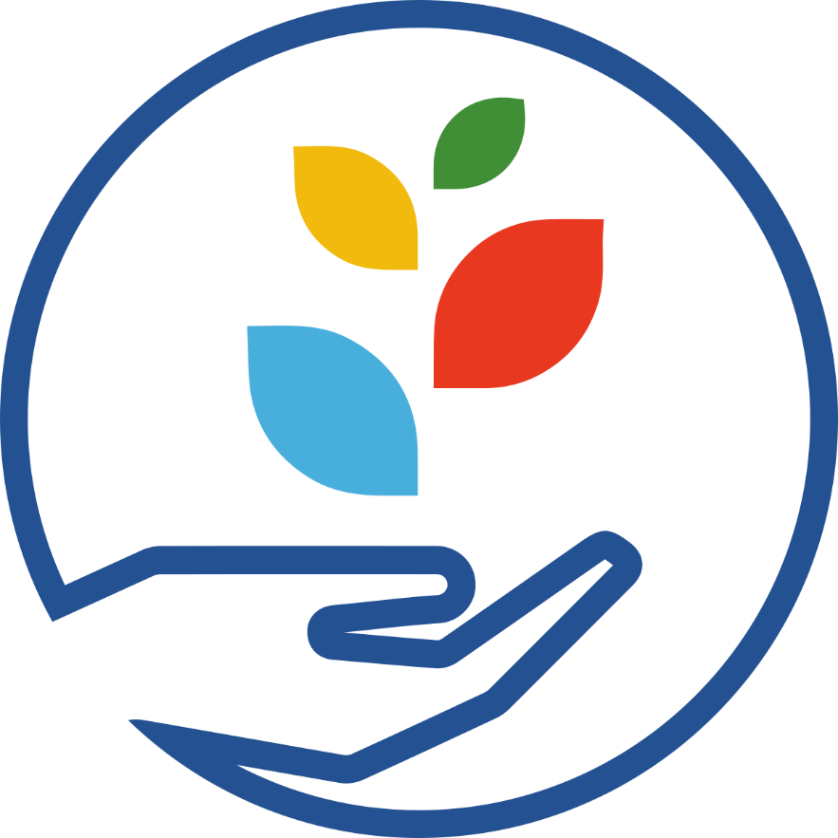

Digital Collections Stewardship Workbook for
Indigenous Practitioners

Action planning workbook for the DCS course series
OCLC/WebJunction 2026

The Digital Collections Stewardship Workbook: A Community-Grounded Action Planning Workbook for Digital Stewardship

This workbook contains the activities for all 8 DSC courses and is intended to guide practitioners in developing community-centered, culturally grounded digital collections. Rather than functioning solely as a technical planning tool, this workbook supports the creation and care of digital collections as living knowledge systems – rooted in relationships, responsibilities, and cultural continuity.
The Digital Stewardship Lifecycle stages: Prepare, Gather, Enhance, Save, and Share – are presented as interconnected and cyclical processes. Within Tribal and Indigenous contexts, stewardship is guided not by rigid workflows but by:
- Community authority and governance
- Cultural protocols and responsibilities
- Intergenerational knowledge transmission
- Relationships to land, ancestors and future generations
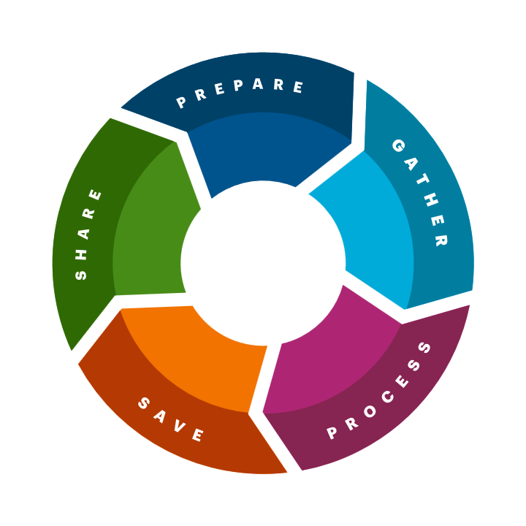

This workbook encourages practitioners to:
- Center Tribal sovereignty and community authority over cultural knowledge/ community knowledge.
- Ensure collections serve collective benefit across generations.
- Practice ethical stewardship grounded in responsibility.
- Apply FAIR (Findable, Accessible, Interoperable, Reusable) principles in ways that do not override cultural protocols or restricted knowledge systems.
All activities are best approached collaboratively – with Elders, Culture Bearers, Tribal leadership, and community members, when possible – recognizing that knowledge stewardship is a shared responsibility.

We thank Selena Ortega-Chiolero for developing this edition of the Digital Collections Stewardship Workbook for Indigenous Practitioners.

Digital Collections Stewardship 1: Introduction

Activity 1: Digital collections
Reflect on what digital collections are and how they function within your community. On the Digital Collections Examples slide, practitioners at six small institutions described the digital collections they have created.
- Choose one of the six institutions from the Digital Collection Examples slide. Listen again to their description and look through their digital collections. How does the collection reflect relationships to community, land, and ancestors? Whose voices are centered, and who may be missing?
- List any digital collections your institution currently has. How are cultural protocols, access restrictions, or responsibilities reflected (or not)? Note who is responsible for creating and maintaining these systems.
- Inspired by what you observe, what elements would you want to include in your digital collections to ensure they reflect community-defined values, knowledge systems, and responsibilities? List your ideas for new digital collections while considering what stories, histories, and knowledge systems should be represented, what cultural responsibilities are tied to these materials, and what formats (oral histories, photos, documents, language recordings) are appropriate? It’s OK if you’re unsure; we’ll revisit this question in the next course!

Activity 2: Focusing on your community
To get started thinking about the Digital Stewardship Lifecycle, take time to reflect on your community and institutional values, culture, and languages. Before discussing community or cultural needs, it is important to understand who makes up your community, including Indigenous groups that steward or have stewarded the land you live on. We encourage you to discuss these questions with colleagues as well.
Before beginning this activity, be sure to review the FAIR (Findable, Accessible, Interoperable, Reusable) principles.

- Who are the original and current stewards of the lands where your institution operates? What Nations, communities, and knowledge systems are connected to this place?

- Which communities are currently represented in your collections? Which have been excluded, misrepresented, or described through non-Indigenous frameworks?

- Who currently holds decision-making authority over how knowledge is collected, described, and shared? How are Tribal governance structures, Cultural Committees, or Elders involved?

- Who should be included in decision-making processes moving forward?
- How will your work reflect:
- Authority to Control (CARE)
- Ethical stewardship (CARE)
- Culturally appropriate access (adapted FAIR) (How can materials be findable and reusable within appropriate cultural boundaries?)

Activity 3: Digital Stewardship Lifecycle customization brainstorm
Brainstorm how your Digital Stewardship Lifecycle can reflect:
- Seasonality, ceremony, and community rhythms (not rigid timelines)
- Cultural review processes (e.g. Cultural Committee or IRB approvals)
- Layered access protocols (public, Tribal-only, restricted, sacred)
- Reciprocity and benefit to community
- Ongoing long-term relationships, not one-time projects
Record all your ideas below.
We’ll come back to this list later in the training. For now, these are just possibilities to consider.

A Community-Centered Approach to Digital Collections

Activity 1: Popular and lesser-known narratives
Take a moment to write down any existing digital collections as well as ideas you have for new projects. Then, consider the stories each collection tells. Consider how collections reinforce or challenge colonial narratives, support cultural revitalization and language preservation, and/or restore community-defined meaning and relationships. If you’ve taken Digital Collections Stewardship 1: Introduction and completed Activity 2, refer to your notes in your workbook to compare how well your current plans represent the full range of experiences in your community.

Example:
Existing collection: Digitized newspapers
Newspaper articles often reflect the priorities and values of the dominant voices in a community to write and shape the news, especially those in power.
Idea for new collection: Oral histories from veterans
Complementing a collection of digitized newspapers with first-person narratives from people with connections to historical events can help to create a fuller picture of the lives and histories beyond the headlines.

Activity 2: Brainstorming connections
This brainstorm is intended to provide a starting point for possible relationships and connections that could bring more diverse voices and perspectives to your digital collections work. ​
Choose the option that feels most useful to you. ​
- Your connections within your organization: If you work for a large organization, draw a map or make a list of all the meaningful connections you have to other departments within your organization. For example, if you work in technical services but are friendly with a colleague who’s a children’s librarian, draw the connection between yourself and that colleague.​
- Your connections to your communities: Draw a map or make a list of your connections to groups or organizations where you feel you personally belong; this can give you an idea of starting points where you already feel comfortable. This might include schools, religious organizations, gyms, volunteer groups, or other groups.​

Activity 3: Reaching out
As you continue through this section, write down some notes to yourself about how these topics might apply to your work:
- What does “moving at the pace of trust” look like when working with Tribal communities?
- How will you ensure that engagement is not extractive, but reciprocal?
- What responsibilities do you carry when working with community knowledge?

- What do you need to do or learn about before you begin this work?

- What permissions or protocols must be followed before gathering or sharing knowledge? How can you modify or leverage your existing events or celebrations to help build trust, relationships, and connect with new communities?

Activity 4: Sustaining relationships
Write down any ideas about your next steps in this section. You can respond to these prompts or add anything else that you think of.​

List any strategies for maintaining relationships in your current and future digital collections projects that you want to keep in mind.

The course mentions utilizing newsletters, social media, a website, and print materials as communications channels with your communities. Write down any existing or new channels you might use to keep your organization and digital collection project visible.

Digital Collections Stewardship 2: Preparing

Activity 1: Group brainstorm: Digital stewardship goals
If possible, we recommend working with colleagues to brainstorm answers to the question below (this also works as an individual exercise).
First, write as many ideas as you can for each question on a large surface like a whiteboard or large sheet of paper.
Next, narrow down your responses for each question to the few ideas that seem most important. Write those down below. You’ll use these answers when creating your Digital Stewardship Purpose Statement later in this course.

- Why do you want to create and share digital collections with your community? Consider: cultural revitalization, knowledge preservation, and intergenerational learning.

- What existing opportunities for collections do you have? How might these opportunities serve and support your community?

- What are some challenges you might face? Whom might you talk to or collaborate with to come up with ways to respond to these challenges?

Activity 2: Digital stewardship purpose statement
Use this space to begin drafting your purpose statement. You can refine this as you go. When drafting your purpose statement, consider:
- How your work supports collective benefit and cultural continuity.
- How your institution will honor Tribal authority over knowledge.
- How access will be carefully balanced with cultural responsibility.
- How your collections will remain usable and meaningful for future generations.
- Write down some key statements from your organization’s mission, goals, values, and/or objectives.

- Write down what is known about your community’s needs, values, and priorities that are relevant to your digital collections work. Refer to the “Focusing on your community” activity from the Course 1 workbook.

- Define your goals for digital collections. Take the most important goals and objectives for your digital collections that you recorded in the Group Brainstorm: Digital Stewardship Goals activity. Refine and combine these so you end up with one or two statements that best align with your organizational goals and community needs. Be specific about who will benefit.

- Start drafting a short (2-4 sentence) purpose statement that connects your larger institutional goals and community needs to your digital collections goals and stewardship goals, to describe what you want to do and why you want to do it. Ensure your statement reflects collective benefit, community authority, and ethical responsibility. See the examples in the Digital Stewardship Purpose Statement section of the course.

Activity 3: Digital stewardship policies
Review your institution’s existing policies for any information specific to digital collections, including digitization, preservation, culturally appropriate access, and use. Take note of whether these topics are addressed; if so, the names of the policies where they appear, and whether they need revising to provide guidance for your digital collections. Also, consider how Tribal laws, cultural protocols, and community-defined culturally appropriate access conditions are reflected in your policies. If you’re not sure yet, that’s ok! We’ll return to these policies in later courses.
Note below the policy topics your institution has already documented and indicate whether that documentation appears to be sufficient for digital collections:

- Digital Collection Development (e.g., criteria for inclusion of materials; guidelines for reappraisal and deaccessioning)

- Digitization (e.g., guidelines for identifying and prioritizing what to digitize)

- Digital Preservation (e.g., guidelines for securely storing digital living knowledge systems)

- Donations (e.g., review procedures, criteria for acceptance, disposition of physical objects)

- Access and Use (e.g., metadata procedures, intellectual property, copyright and permissions, conditions of use, such as non-commercial or restricted)

- Traditional Knowledge (TK) Labels or similar frameworks

- Cultural sensitivity review processes

- Protocols for sacred, restricted, or seasonal knowledge

- Community review authority prior to access or publication

- Any additional policies you think may be relevant:

- What’s missing in your existing policies? What new policies might you want to create? Who decides if new policies are needed? Who would be involved in drafting them? What is the approval process? Below, write down your initial thoughts about the need for future policy work.
(We’ll explore specific policies in more detail in later courses, so you don’t need to create any new policies at this time.)

Activity 4: Guiding questions to set up your project
Use the guiding questions below to begin planning your first digital collections project. You can also refer to the examples and tips shared in Guiding Questions in Section 4 of the course. You may not have all the information you need at this point. That’s fine, you can continue to refine and add information here as you work through the courses and plan your project.
WHAT project will you begin with? (Consider starting small.)
WHO will be involved? (Include employees, volunteers, internal stakeholders, external partners, community members, and knowledge holders.)
HOW will you complete the work? What tools, resources, or potential funding will you need? (We recommend starting with what you have, where relevant.)
WHEN will you do this work? What’s the timeline? (Give yourself more time than you think you’ll need and embrace flexible timelines for your first project to allow flexibility for community processes.)

Digital Collections Stewardship 3: Gathering

Activity 1: What to include
As you learn about collections considerations in Section 2: What You’ll Include, note your initial thoughts on these four aspects of the items you will include in the collection you are planning.
- Subject (Consider what subjects are appropriate to include, and what is out of scope)
- Cultural, ethical, or legal issues:
- What cultural protocols govern these materials?
- Who has authority to grant permission for:
  - Digitization
  - Description
  - Access
- Are there materials that should not be digitized or shared?
- How will you ensure free, prior, and informed consent (FPIC)?

- Physical items (If you accept them, what are your limits)
- Condition (Consider minimum standards for digital, acceptable conditions for physical)

Activity 2: How to gather items
As you proceed through Section 3: How You’ll Gather Items, record your thoughts when prompted about each of the three methods described. After taking time to reflect individually, we recommend talking through these options with others in your institution or community.

- Community contributions (How will you ensure respectful, reciprocal engagement?)
- External Partnerships (How will you maintain community authority?)
- Creating new content (How will contributors have control over their knowledge?)

Activity 3: Document the “what” and the “how”
Now that you have decided what types of items you’ll gather, and how you’ll go about gathering them, you can connect those decisions with either the policies you reviewed in Activity #3 of Course 2: Preparing, or with the appropriate procedures, forms, and collection-level documentation for each. Ensure all documentation reflects cultural protocols, and community-defined expectations.
Policies
Note which “what” or “how” collecting guidelines you think should be documented at the policy level, and the name of that policy (if known).

Procedures
Note anything that represents an ongoing procedure, something you wouldn’t include in a policy.

Forms
Note any process that will require a form, and whether one exists in your institution (include whether it will need updating).

Collection documentation
List guidelines that are specific to your proposed collection but might also apply to any digital collection you develop.

Digital Collections Stewardship 4: Digitizing

Activity 1: Digitization process, equipment, and standards
As you learn about the process of digitizing different types of items, record your initial understanding of the process for your collection. If needed, make a copy of these questions for each item type you want to digitize.
Item Type:
- Item type variations – describe the variations and conditions of items to be digitized. Include important details such as physical condition, size, media formats, etc.

- Process options – given what you know, describe the appropriate digitization process you expect to use. If uncertain, note the options and your questions about them.

- Equipment needs – list all physical equipment you think you’ll need. Indicate which ones you currently have, which you can borrow, and which might need to be purchased.

- Software / file editing – describe the kinds of software you will need, whether you currently have it, and which you will need to obtain

- File formats – refer to one of the technical guidelines from the Digitization standards and technical specifications list in the Digitizing course external links handout to identify file formats and quality standards you might use. Note where you are not yet certain which ones to use. Ensure that preservation quality supports long-term access and digitization respects cultural protocols.

Activity 2: Strategies for digitizing
As you learn about the advantages and drawbacks of each digitization strategy, note those that relate to your situation. Consider control over materials, cultural sensitivity, and data sovereignty. Also note where you need additional information or follow-up, and any decisions about each that you’ve already made.
1. In-house digitization, i.e., doing the work yourself

2. Sharing digitization work with a partner organization or institution

3. Hiring a digitization vendor

Activity 3: Documentation
Note below which, if any, of these forms of documentation already exist at your institution, and which ones you might want to create. Briefly describe the scope of what you want to document, and any initial questions you might have about each one. Identify needs for policies, procedures, workflows and project plans.

Digitization policy

Digitization guidelines and procedures

Digitization project plan

Digitization workflows

Digital Collections Stewardship 5: Enhancing

Activity 1: Folder structure and file naming
Review the digital collection project you identified in Activity #4 of Course 2: Preparing. With that project in mind, respond to the following questions with ideas for your folder structure and file naming conventions.

- What is your current folder structure scheme? Does it reflect your institutional and workflow needs? Do you have more than four levels of folders?

- Do you already have a file-naming scheme in place? Does it reflect your current file management needs? Does it include all your digital content? Do your naming conventions reflect cultural and contextual information?

- Are you required by policies or mandates to name and save your digital files in a certain way?

- Does your file-naming scheme need to mirror or extend a paper-based scheme or environment?

- What information is most important to capture in your file names?

- Are there limitations on the length of the file name, including software, computer system, or storage device limitations?

Activity 2: Review description and metadata
Review existing descriptions of items and collections with these questions in mind:
- Who is providing the description? Is it community-defined or externally imposed? Identify bias or gaps whenever possible.

- How will you incorporate:
  - Indigenous language
  - Cultural knowledge fields
  - Community narratives

- How will you correct or contextualize harmful or outdated metadata? Use standards where helpful and adapt them to reflect relationships, place, and meaning when appropriate.

Identify any questionable sources and descriptions. Flag existing descriptions that may need revision, additional information, or perspectives added.
- What are some groups or communities that might have a connection to the living knowledge systems/items you are describing?

- How might you learn more about the communities or groups associated with this collection and build relationships with them? What kinds of outreach might you develop to connect them to the collection and support the sharing of stories and context?

- What other resources might you use to help guide this work?

Review the completeness of your metadata:
- Note any metadata standards, content guidelines, or classification schemes you are using.

- Compare your existing descriptive information with the fields of the metadata standard you have chosen. If you haven’t yet chosen a standard, refer to the Dublin Core Metadata Elements handout.

- How will your metadata reflect:
  - Relationships (people, place, kinship)
  - Cultural meaning (not just subject terms)

- Assess the overall completeness of your description/metadata, focusing first on any required fields. Briefly describe a plan for filling in any gaps, including who will be responsible for resolving these gaps.

Digital Collections Stewardship 6: Saving

Activity 1: File storage planning
As you learn about archival digital file storage practices, record your responses to the questions. It is likely that you won’t yet be able to answer all the questions. If you don’t know an answer, consider how you will find it.

- What are your two types of storage media?

- Who is responsible for selecting the storage media options for your organization?

- Who is responsible for the setup and maintenance of storage media and technology?

- Who is responsible for maintaining duplicate storage of files in multiple locations?

- When will new files be duplicated? Who will do this work?

- Where will funding for storage space and replacement storage come from? Who will be responsible for making the budget requests for storage costs?

- What versions of your files exist, and which versions will be backed up? For instance, will you only save multiple copies of preservation files?

- Disaster planning: What will happen if a disaster strikes? Who is responsible for damage assessment, and how will your files be recovered?

- How does your storage and preservation approach ensure:
  - Long-term community access
  - Protection of sensitive knowledge
  - Sustainability for future generations

Activity 2: File integrity planning
As you learn how to ensure the integrity of your digital files, record your current responses to the questions in this sheet. It is likely that you won’t yet be able to answer all the questions. In your planning, remember to consider how you are ensuring community trust and ethical stewardship. If you don’t know an answer, consider how you will find it.

    - Who is responsible for the integrity of your digital files?

    - Technical support: Who is responsible for setting up, managing, and implementing file integrity technology/systems?

    - Fixity: How will you run fixity checks? What tools will you use, and where will this information be stored?

    - Security: Who is responsible for the security of digital files? How are security measures enforced?

    - Authenticity: How will you ensure the authenticity of your files? Who is responsible? Are there any specific concerns around authenticity?

    - Virus checks: Are regular virus checks run on systems? Who is responsible?

    - Funding: What is the source of funding for any software or hardware needed to support file integrity efforts?

    - Disaster planning: What will happen to file integrity after a disaster event?

Activity 3: File access planning
As you learn about archival digital file access practices, record your current responses to the questions in this sheet. It is likely that you won’t yet be able to answer all the questions. If you don’t know an answer, consider how you will find it.

    - Who is responsible for handling access concerns for digital files?

    - Technical support: Who is responsible for setting up and managing file access tools or processes?

    - Metadata: What preservation metadata is collected, who is responsible for it, and where/how is it stored?

    - File formats: What file types have you decided on for the different formats and versions of digital files?

    - Migration of storage and file types: How will you know when it is time to get new storage media? How will you keep updated on file types and determine when to convert files to different types or formats?

    - Funding for access: What amount of funding do you require to obtain any tools needed to support your digital preservation activities? What might be some sources for that funding?

Digital Collections Stewardship Workbook 7: Sharing

Activity 1: Review your goals and collections
Reflect on the following questions:

- Why are you sharing your digital collections? Refer to the digital stewardship goals you identified in Activity #1 of Course 2: Preparing.

- Who is the primary audience for these living knowledge systems? Are there any secondary audiences? Where are they located, and what are their needs?

- Who should have access – and who should not? Will you share your digital collections online or only with people visiting your physical institution? If online, will the collections be freely available? Will Community members/Knowledge holders/Relatives need to be authenticated?

- What types of files are in your collection? Primarily images and documents, or audio and video?

- Are there any copyright or donor restrictions for items in your digital collections? How will these restrictions be managed, and Community members/Knowledge holders/Relatives informed? Are digital collections intended to be a permanent offering at your institution?

- What materials require:
  - Tiered access
  - Seasonal access
  - Community-only access

- How will you ensure CARE: Authority to Control?

- How will you communicate conditions of use clearly and respectfully?

Activity 2: Sharing methods
As we describe the range of options for sharing your collections in this section:
- Note which ones you currently have culturally appropriate access to or seem to be possible options for your institution.
- Record any thoughts about which options are most suitable for sharing your institution’s digital collections and why.
- Record initial questions you have about them or additional information that would help in decision making.
- Note how your sharing methods reflect Indigenous data sovereignty and how they respect cultural protocols.

- Dedicated institutional website
  - Static website

  - Content management system

- External archives

- Social media

- Photo and video sharing sites

- Exhibits, education. and outreach

Closing Reflection
Digital stewardship is not just about managing files. It is about honoring relationships, responsibilities, and knowledge systems.
As you complete this workbook, consider the following:
- How your work supports community continuity
- How it respects ancestral knowledge
- How it serves future generations

Appendix A:
Tribal Practitioner Spotlights - Stewardship in Practice
The frameworks discussed throughout this workbook—including Indigenous Data Sovereignty, CARE Principles, Traditional Knowledge Labels, and relational stewardship—are not theoretical concepts alone. Indigenous communities, Tribal Nations, and cultural heritage organizations are actively implementing these approaches in archives, museums, libraries, language programs, and digital collections initiatives around the world.
The following examples demonstrate how stewardship practices can be adapted to support community authority, cultural continuity, and Indigenous self-determination.
These examples are intended to inspire reflection rather than prescribe a single approach. Every community has its own governance structures, priorities, cultural protocols, and stewardship practices.

Chickaloon Village Traditional Council (Alaska)

Stewardship Focus:
Digital Repatriations, Relational Stewardship, Community-Grounded Access
Chickaloon Village Traditional Council (CVTC), an Ahtna Dene Tribe in southcentral Alaska, has developed a digital stewardship model centered on reconnecting community members with historical photographs, documents, oral histories, and cultural heritage materials dispersed across external repositories.
Through its Mukurtu-based digital archive, Ugheldze Hwle Cilaes (“Sharing and Caring: Information We Share”), CVTC combines institutional metadata with community-sourced knowledge and cultural context. Materials are organized according to Ahtna family relationships and community knowledge structures rather than solely institutional classification systems.
Key stewardship practices include:
- Community review of descriptions and metadata
- Shared stewardship agreements with partner institutions
- Digital rematriation alongside physical repatriation efforts
- Integration of Traditional Knowledge considerations into access decisions
- Ongoing consultation with Elders, Cultural Committee members, and community representatives
- Implementation of an Ahtna subject headings and nomenclature naming schema

Reflection Questions
- How might your collections better reflect community-defined knowledge structures?
- Are there opportunities to reconnect dispersed materials with source communities through digital stewardship?
- How might shared stewardship strengthen relationships with external institutions?

Plateau Peoples’ Web Portal (Washington & Oregon)

Stewardship Focus:
Collaborative Curation and Shared Authority
The Plateau Peoples’ Web Portal was developed through collaboration between Tribal communities of the Columbia Plateau and regional museums and universities.
The project created opportunities for Tribal community members to contribute descriptions, cultural knowledge, language information, and community perspectives to collections held by external institutions.
The portal demonstrates how stewardship can move beyond institutional description toward collaborative knowledge creation.
Key practices include:
- Community-authored metadata
- Tribal language integration
- Multiple perspectives represented in descriptions
- Ongoing consultation and relationship-building

Reflection Questions
- Who currently creates descriptions for your collections?
- How might community members participate in interpretation and description?
- What perspectives may be missing from existing records?

Indigenous Archives Collective

Stewardship Focus:
Building Indigenous Archival Capacity
The Indigenous Archives Collective supports Indigenous memory workers and community stewards through training, advocacy, and professional development.
The organization recognizes that Indigenous archival practice is grounded not only in technical skills but also in relationships, cultural responsibilities, and community accountability.
Key themes include:
- Indigenous-led stewardship
- Capacity building
- Community archives
- Relationship-centered practice
- Professional networks of support

Reflection Questions
- What stewardship knowledge already exists within your community?
- What training or support might strengthen local capacity?
- How can stewardship responsibilities be shared across generations?

Smithsonian Recovering Voices Initiative

Stewardship Focus:
Language Revitalization and Knowledge Reconnection
The Recovering Voices initiative supports Indigenous communities in reconnecting with language recordings, archival materials, ethnographic documentation, and other cultural resources held by museums and archives.
The initiative emphasizes collaboration, community priorities, and the return of knowledge in forms that support language revitalization and cultural continuity.
Key lessons include:
- Stewardship can support language revitalization
- Access should be driven by community priorities
- Digital return can be a meaningful form of reconnection
- Institutional partnerships can support community-defined goals

Reflection Questions
- How might your collections support language and cultural revitalization efforts?
- What forms of knowledge return would be meaningful to your community?
- How can stewardship contribute to cultural continuity?

Concluding Reflection
While stewardship technologies, policies, and procedures may vary, the examples above share several common principles:
- Relationships before transactions
- Community authority before institutional convenience
- Responsibility alongside access
- Reciprocity rather than extraction
- Stewardship for future generations
As you continue through the Digital Collections Stewardship course series, consider how these examples relate to your own community, institution, and stewardship responsibilities.
The goal is not to replicate another community’s model, but to develop stewardship practices that reflect your own values, governance structures, cultural protocols, and visions for the future.

Appendix B: Recommended Resources for Continued Learning and Practice
The following resources provide additional guidance on Indigenous data governance, digital stewardship, community archives, culturally responsive collections care, and Indigenous approaches to access and stewardship. Facilitators and learners are encouraged to explore these resources alongside the Digital Collections Stewardship course series.
While no single framework will meet the needs of every community, these resources offer important perspectives that can help practitioners build stewardship programs grounded in community authority, reciprocity, cultural responsibility, and long-term care.

Indigenous Data Sovereignty and Data Governance
Global Indigenous Data Alliance (GIDA)
The Global Indigenous Data Alliance is an Indigenous-led international organization that promotes Indigenous Data Sovereignty and the CARE Principles.
Topics include:
- CARE Principles
- Indigenous Data Governance
- Data Sovereignty
- Community-centered stewardship

Carroll, S. R., Garba, I., Figueroa-Rodríguez, O. L., Holbrook, J., Lovett, R., Materechera, S., Parsons, M., Raseroka, K., Rodriguez-Lonebear, D., Rowe, R., Sara, R., Walker, J., & Anderson, J. (2020). The CARE Principles for Indigenous Data Governance. Data Science Journal, 19(43), 1–12.
The foundational publication introducing the CARE Principles for Indigenous Data Governance and their application across research, archives, libraries, museums, and information stewardship.

Indigenous Knowledge Labels and Cultural Authority
Local Contexts
Anderson, J., & Hudson, M. (Eds.). Local Contexts Initiative.
Local Contexts provides Traditional Knowledge (TK) Labels, Biocultural Labels, and Notices that help Indigenous communities communicate cultural authority, permissions, responsibilities, and protocols associated with knowledge and cultural heritage materials.
Topics include:
- Traditional Knowledge Labels
- Community attribution
- Cultural permissions
- Indigenous intellectual sovereignty

Indigenous Archives and Libraries
Protocols for Native American Archival Materials (PNAAM)
First Archivists Circle. (2007). Protocols for Native American Archival Materials.
A foundational document outlining culturally responsive approaches to stewardship, consultation, access, description, repatriation, and relationship-building between repositories and Native communities.
Topics include:
- Cultural sensitivity
- Community consultation
- Archival access
- Stewardship responsibilities

Indigenous Archives Collective
The Indigenous Archives Collective supports Indigenous archivists, memory workers, and community stewards through training, advocacy, and professional development.
Topics include:
- Community archives
- Indigenous archival practice
- Professional development
- Relational stewardship

Indigenous Museum Practice
Lonetree, A. (2012). Decolonizing Museums: Representing Native America in National and Tribal Museums. University of North Carolina Press.
A foundational text examining how museums can address colonial histories and support Indigenous self-representation, truth-telling, and healing.
Topics include:
- Decolonization
- Community voice
- Indigenous representation
- Museum ethics

Peers, L., & Brown, A. K. (Eds.). (2003). Museums and Source Communities. Routledge.
An important collection of case studies exploring collaborative relationships between museums and Indigenous communities.
Topics include:
- Shared stewardship
- Collaboration
- Community engagement
- Knowledge exchange

Indigenous Digital Stewardship
Mukurtu Content Management System
Mukurtu is an Indigenous-designed content management system that supports culturally responsive digital stewardship through community-defined access protocols and relationship-based knowledge management.
Topics include:
- Community protocols
- Traditional Knowledge Labels
- Tiered access
- Digital stewardship

Christen, K. (2015). Tribal Archives, Traditional Knowledge, and Local Contexts: Why the “s” Matters. Journal of Western Archives, 6(1).
Explores Indigenous approaches to digital stewardship and the importance of local context in managing cultural heritage materials.

Indigenous Research and Community Governance
First Nations Information Governance Centre (FNIGC).
The OCAP® Principles—Ownership, Control, Access, and Possession—provide a framework for First Nations data governance and community control over information.
Topics include:
- Community authority
- Research governance
- Information management
- Data sovereignty

Kovach, M. (2021). Indigenous Methodologies: Characteristics, Conversations, and Contexts (2nd ed.). University of Toronto Press.
A foundational text for understanding Indigenous ways of knowing, relational accountability, and Indigenous approaches to knowledge creation and stewardship.

Wilson, S. (2008). Research Is Ceremony: Indigenous Research Methods. Fernwood Publishing.
An influential work describing relational accountability and Indigenous knowledge systems.
Topics include:
- Relationality
- Accountability
- Community responsibility
- Indigenous epistemologies

International Indigenous Cultural Heritage Frameworks
Tandanya–Adelaide Declaration
International Council on Archives (ICA) Expert Group on Indigenous Matters.
The Tandanya–Adelaide Declaration calls for the recognition of Indigenous rights, authority, and participation in archival stewardship and decision-making.
Topics include:
- Indigenous rights
- Self-determination
- Archival stewardship
- Community authority

United Nations Declaration on the Rights of Indigenous Peoples (UNDRIP)
United Nations. (2007). United Nations Declaration on the Rights of Indigenous Peoples.
Articles relating to cultural heritage, traditional knowledge, language, intellectual property, and self-determination provide an important foundation for Indigenous stewardship work.

Reflection for Continued Learning
As you continue your stewardship journey, consider:
- Which frameworks most closely align with your community’s values and governance structures?
- How might these resources strengthen your institution’s stewardship practices?
- What additional community-specific protocols should guide your work?
- How can you continue building relationships that support ethical, reciprocal stewardship?
- What responsibilities do you carry as a steward of cultural knowledge?
- Digital stewardship is an ongoing practice of care, reciprocity, learning, and accountability. These resources provide starting points for strengthening stewardship relationships and supporting community-defined futures.

